Board of Directors- Lake Shore Realty Limited
1.  Mr. Vinit Kumar  Additional Director  (Managing Director) | 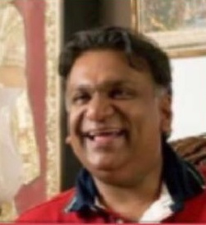 | First-generation serial entrepreneur with over 30 years of experience building technology-led ventures across real estate, agriculture, food processing, technology and ITeS. Chairman of the Indigo Group of Companies since 1996, and founder of iMandi, a rural social commerce platform built in partnership with IFFCO, as well as Indigo Infracon and Trustpay Education Service. Founded one of the largest food park projects in West Bengal and has introduced leading European and US technology companies to Indian markets. Director of Indigo Heritage Foundation, which is digitizing 20 million palm-leaf manuscripts, and a member of the Advisory Board of SNDT Women's University. Holds an MBA from the University of Notre Dame, USA, and a Bachelor of Engineering from Manipal Institute of Technology.
2.  Ms. Bhairavi Chandrakant Goswami  Whole Time Director |  | A visionary entrepreneur and former Bollywood icon, she is the founder of India's only ultra-luxury brand, Bhairavi World. From selling baked goods at eight years of age to studying ancient texts and biohacking for longevity, her journey spans film, philanthropy, wellness, and spiritual exploration. She has also served as editor and publisher at Indigo World, blending artistry with insight. A devoted animal lover, equestrian, and changemaker, she brings a rare mix of glamour, grit, and grounded wisdom to every venture.
3.  Mr. Chandan Hiralal Prajapati  Non-Executive Director | 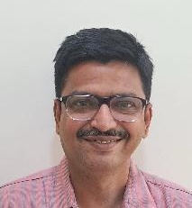 | Dynamic entrepreneur and multi-sector business leader with over 9 years of experience as a Director and Partner across multiple companies and LLPs. Expertise spans infrastructure, real estate, FMCG, e-commerce, marketing networks, organic farming, and investment management. Skilled in strategic planning, business development, and operational leadership for both startups and established ventures.
4.  Mr. Vijay Kumar  Non-Executive  Independent Director | 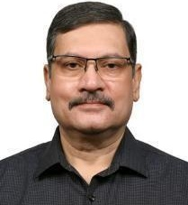 | Seasoned Indian Police Service (IPS) officer with a distinguished 33-year career in the Police Department. Held key leadership roles, including head of Law and Order for Tamil Nadu State, Prisons, Police Housing Corporation, and Vigilance and Anti-Corruption. Possesses extensive expertise in financial investigations and narcotics enforcement. Prior to joining the IPS, served in the Indian Railway Traffic Service (IRTS) with Western Railways (HQ Mumbai), gaining valuable experience in financial management, commercial, and operations management of railways, including goods transport and container movements.
5.  Mr. Narendra K Verma  Non-Executive  Independent Director | 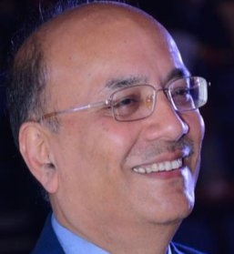 | Seasoned Oil & Gas professional with 46+ years of exploration and production experience including 8 years at board level as Director Exploration and Business Development / Managing Director and CEO of ONGC Videsh, a Fortune 500 international E&P company with global footprints in 22 countries. Proven track record of achieving a 90%+ jump in oil and gas production during challenging periods of global oil price volatility. Actively engaged as entrepreneur, advisor, and AI/ML innovator in the energy sector.

